Phase II: Image Search and Detection

Group 3:

Cody Ambrose, Rodney French, John Kaiser, Orry Newell

University of Maryland Global Campus

Revision: 1.0

Date: 11/29/2020

Class #: CMSC 495

**Revision Log**

|  |  |  |  |
| --- | --- | --- | --- |
| **Rev** | **Date** | **Editor** | **Description** |
| 1 | 11/29/2020 | Cody Ambrose | Original Document |
|  |  |  |  |
|  |  |  |  |
|  |  |  |  |
|  |  |  |  |
|  |  |  |  |
|  |  |  |  |
|  |  |  |  |
|  |  |  |  |
|  |  |  |  |
|  |  |  |  |
|  |  |  |  |
|  |  |  |  |

# User’s Guide

## Phase2_Waldo.py

1. Download the Group3_Phase2.zip folder.

2. Unzip/Extract the contents of Group3_Phase2.zip folder.

3. From Spyder IDE 4.1.4 using Python 3.8.3, open Phase2_Waldo.py.

4. Click the green “Run file” arrow in the tool bar.

5. A GUI should appear (you may need to click over to it in your task bar).

6. Select the “Where’s Waldo” button.

7. The GUI will display a default scene (City) and target image (Waldo).

8. You may choose other scenes from the “Choose scene” dropdown and/or other target image characters from the “Choose character” dropdown.

9. Click the “Preview” button to display your chosen scene to search and target character to search for.

10. Click the “Search” button to initiate image detection for the character you chose.

11. The closest match to the character you chose will be highlighted in a green box within the scene and a zoomed in image of the character in the scene will be provided in the bottom right of the GUI.

12. You may choose other scenes and/or target image characters and repeat the “Preview” and “Search” process to attempt to find the chosen character in the chosen scene or close the application (two windows).

## 

*Note: The target images and “puzzle” images are included in the Group3_Phase2.zip folder at the appropriate file paths for Phase2_Waldo.py to find them. You must run Phase2_Waldo.py from the extracted location within the Group3_Phase2 folder to ensure images are properly pulled and referenced.

# Original Phase II Milestone

The original Phase II Milestone was to create a basic GUI with pre-determined images to locate Where’s Waldo characters within smaller/simpler Where’s Waldo puzzles. This was to be accomplished using OpenCV within a Python programming environment. In addition, rescaling of the images and testing of different template matching techniques to better identify target images was to be performed in this phase.

# Time Management/Schedule

Based on the results of Phase II testing, our group is on schedule according to our Phase II milestone. We have successfully developed a Python program, Phase2_Waldo.py, during Phase II that accomplished most of our goals and prompted additional research into methods and techniques. Furthermore, we identified three simple Where’s Waldo puzzle images as input (City, Zoo, Ski Resort), as well as five target character images we can use to find the Where’s Waldo characters (Waldo, Wenda, Wizard, Odlaw, Woof). The test matrix below shows the results of Phase II:

|  |  |  |  |
| --- | --- | --- | --- |
|  | **City** | **Zoo** | **Ski Resort** |
| **Waldo** | Found | Found | Not Found |
| **Wenda** | Found | Found | Found |
| **Wizard** | Found | Found | Found |
| **Odlaw** | Not Found | Found | Found |
| **Woof** | Not Found | Not Found | Not Found |

# Problems Encountered

The methods we identified to find shapes and different color shapes in Phase I were not complex enough to work for Where’s Waldo characters. Basic template matching would often misidentify other objects within the Where’s Waldo scene as the chosen target image. Instead, we had to explore additional methods within OpenCV to identify a target image within a given puzzle image. We found that template matching with adaptive gaussian thresholding (cv2.ADAPTIVE_THRESH_GAUSSIAN_C) gave us much more accurate results. In addition, a multi-scaling approach had to be incorporated that resizes the puzzle image multiple times, each time searching for the target image within it. This multi-scaling helped to overcome the size differences between our character target images and Where’s Waldo puzzle images.

# Reevaluation

Reflecting on the results of Phase II, we believe that our choice of Python and OpenCV is still the most appropriate solution for our larger “Where’s Waldo” project we are building towards. However, our results show that even template matching, adaptive gaussian thresholding, and multi-scaling combined do not give us 100% accurate results. Additional research in edge detection and feature matching is necessary as we build towards more complex Where’s Waldo puzzles. We also believe that our choice of tkinter for the GUI interface, pathlib library for file paths (to standardize our data file structures across operating systems), input formats (.jpg, .jpeg, .png), output formats (.jpeg), test cases, and performance estimate benchmarks are all still appropriate to carry on to Phase III.

# Results

## Phase2_Waldo.py

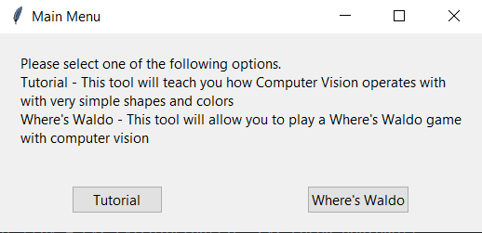

The initial GUI that launches when running Phase2_Waldo.py, click “Where’s Waldo”.

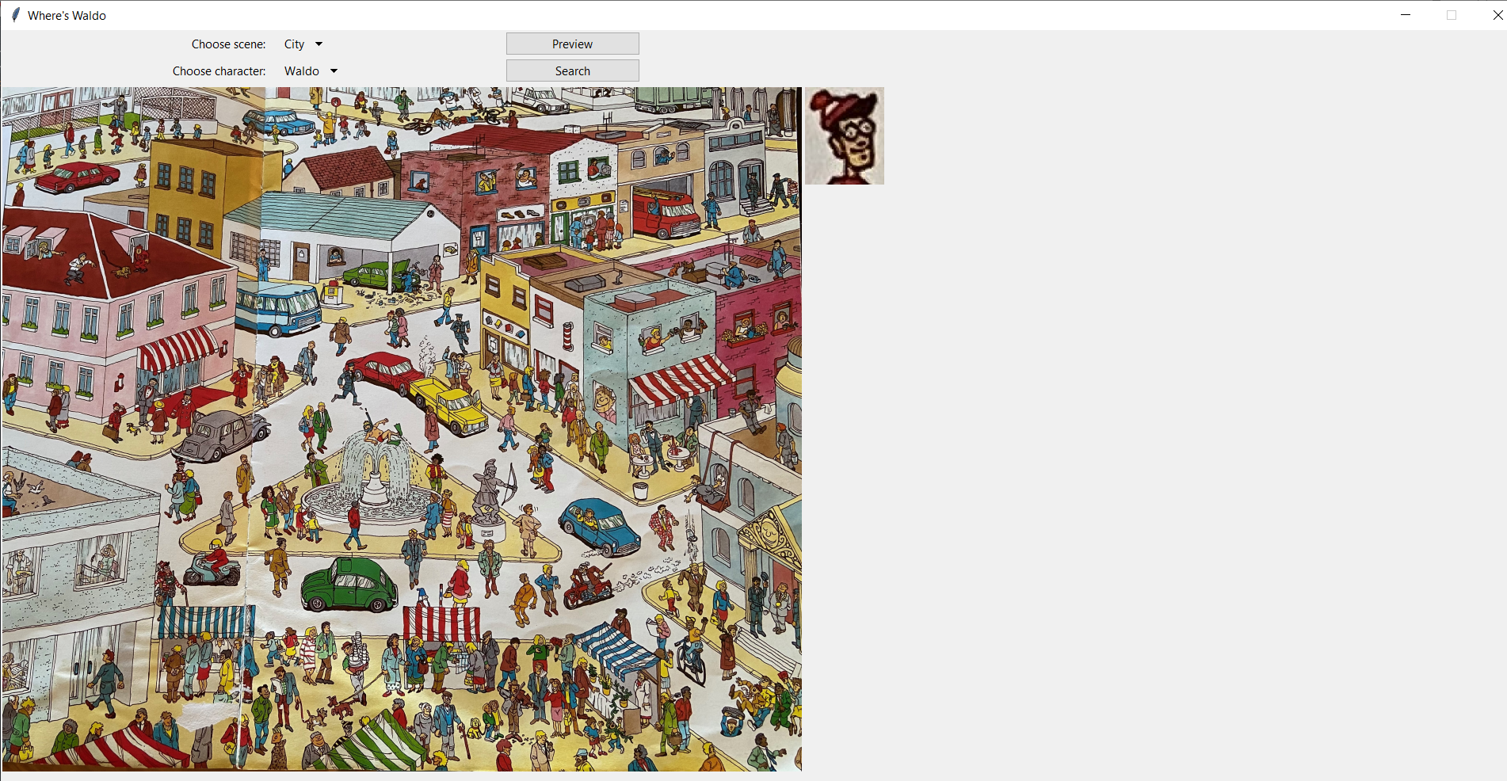

The GUI that is launched when the user clicks “Where’s Waldo”. A default scene (City) and default character to search for (Waldo) are displayed.

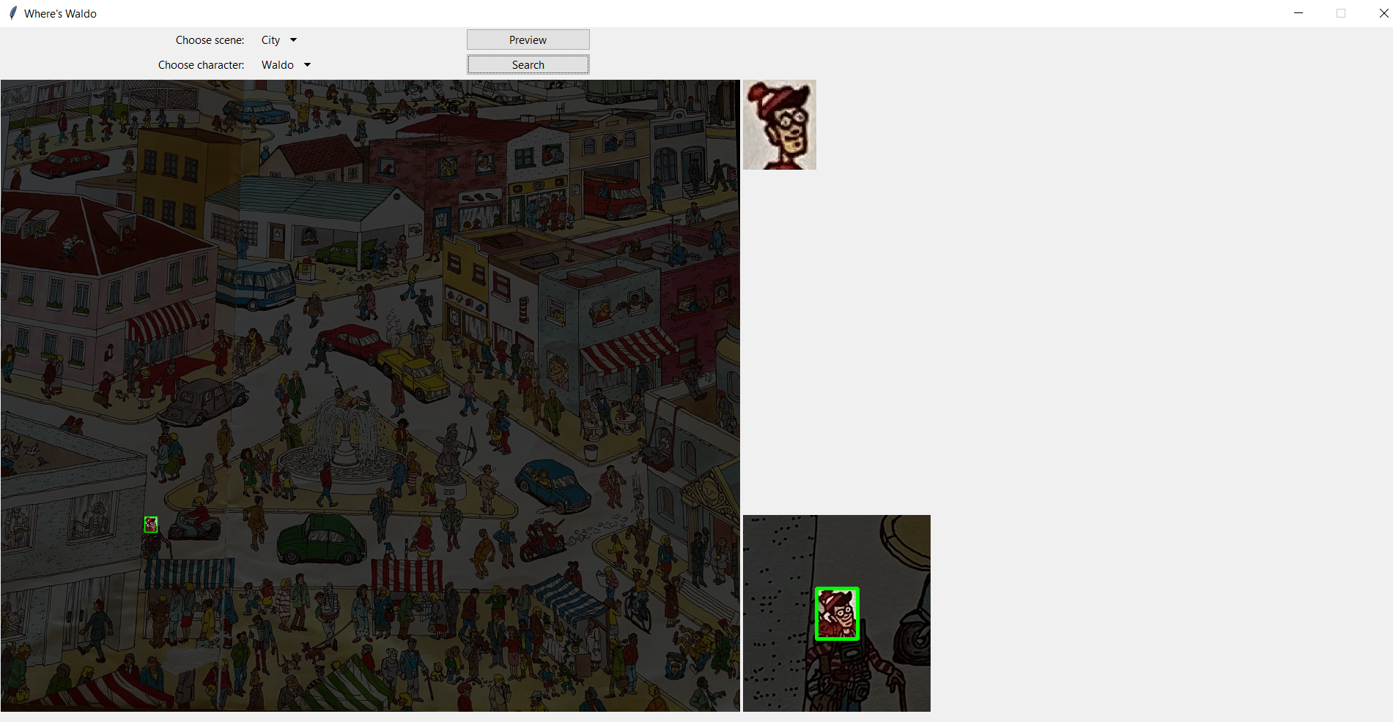

Clicking “Search” finds and outlines the chosen character (Waldo) in the chosen scene (City). Note that a zoomed in image of where Waldo was found appears in the bottom right of the GUI.

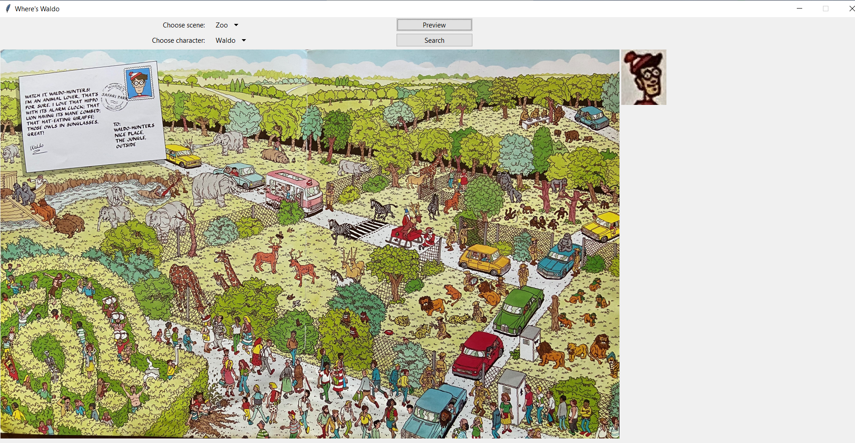

Choosing a new scene (Zoo) and keeping the same character (Waldo), click “Preview” to get to the screenshot above.

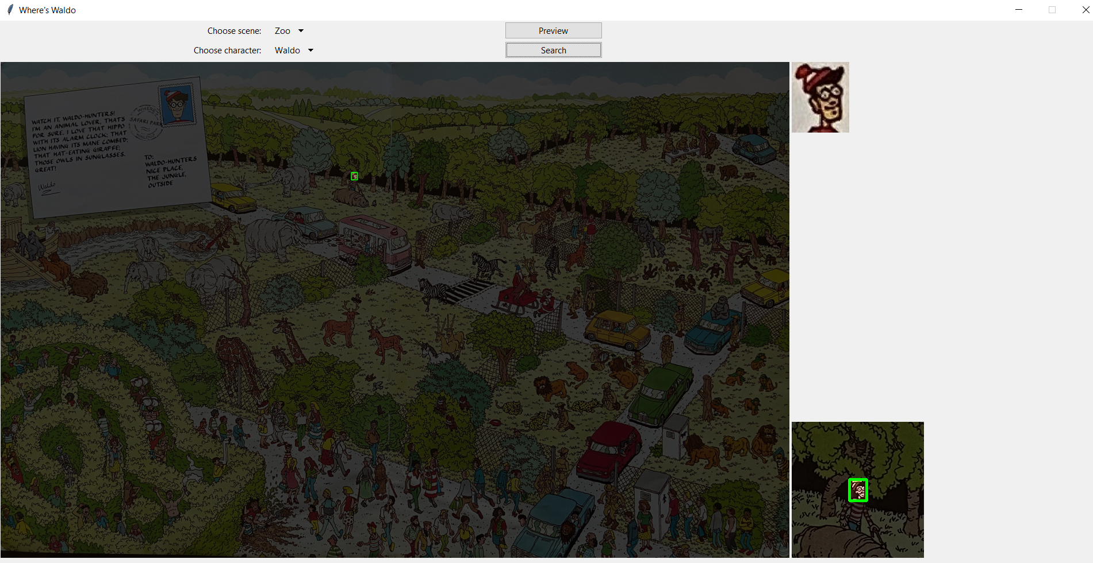

Click “Search” to find Waldo in the Zoo scene.

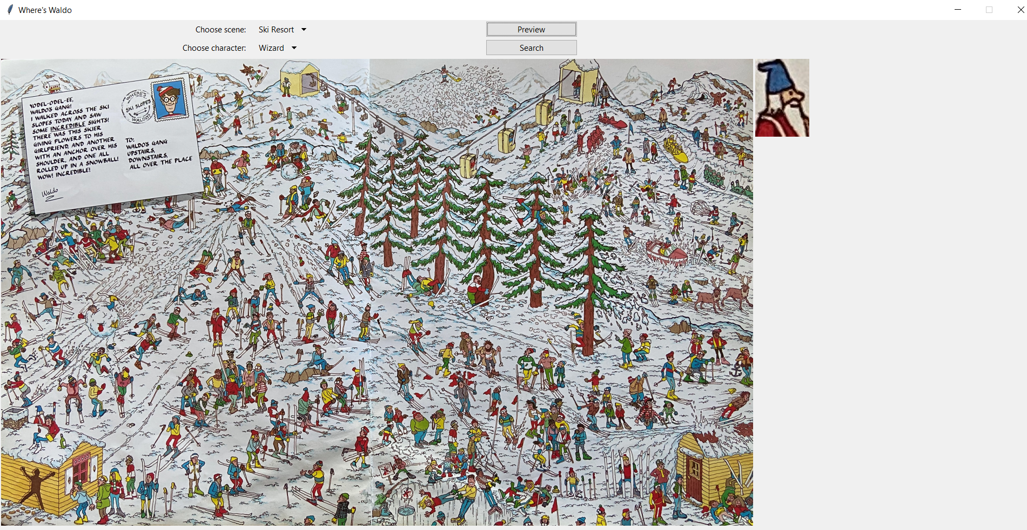

Choose a new scene (Ski Resort) and new character (Wizard), then click “Preview” to get to the screenshot above.

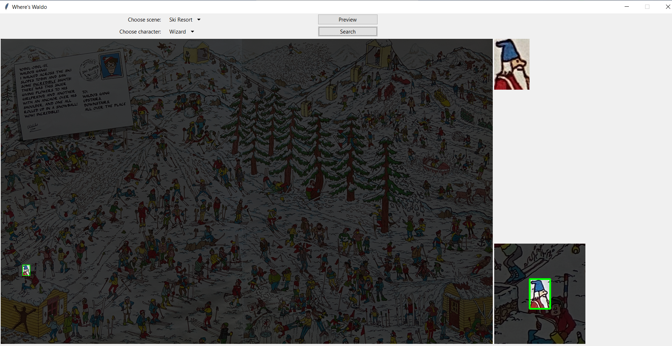

Click “Search” to find Wizard in the Ski Resort scene.

The program finds the user selected Where’s Waldo character within the chosen Where’s Waldo puzzle image according to the test matrix below:

|  |  |  |  |
| --- | --- | --- | --- |
|  | **City** | **Zoo** | **Ski Resort** |
| **Waldo** | Found | Found | Not Found |
| **Wenda** | Found | Found | Found |
| **Wizard** | Found | Found | Found |
| **Odlaw** | Not Found | Found | Found |
| **Woof** | Not Found | Not Found | Not Found |

*Note: In each case where the chosen character was found, the 10-second performance estimate threshold was met.